

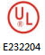
WMZ12A(Ⅰ/Ⅱ) Series

PTC Thermistors正温度系数热敏电阻器
- For Over Current Protection用于过流保护

■ GENERAL 概述
WMZ12A（Ⅰ/Ⅱ）系列PTC热敏电阻器系新一代过流保护器件，其特点是无触点、无噪音、无火花、自动保护、自动复原，可重复使用，其安全性能符合美国UL1434标准要求。
WMZ12A（Ⅰ/Ⅱ）系列PTC热敏电阻器主要用于电子镇流器/节能灯/适配器/充电器/电能表/万用表/通讯设备/微电机等过流保护。如应用示例所示，当被保护电路处于正常状态时，流过PTC热敏电阻器R_{t}的电流小于其最大不动作电流I_{N}，R_{t}处于低阻态，不会影响被保护电路正常工作；当被保护电路遇过流（电流大大超过其动作电流I_{T}令R_{t}急剧发热）等异常状况时，R_{t}骤然跃入高阻态，使被保护电路避免受到损坏。当异常状况消失，温度、电流回复正常后，R_{t}自动回复至低阻态，被保护电路亦回复至正常工作状态。
WMZ12A（Ⅰ/Ⅱ）系列之选型主要考虑R_{t}的电流特性和R_{t}环境温度，其最大不动作电流I_{N}应适度大于被保护电路的额定工作电流，以能及时响应又不会误动作为准则。与此同时，应特别注意Rt之动作/不动作特性与工作环境温度密切相关，I_{N}和I_{T}随工作环境温度T_{A}升高而降低，如图II所示。
WMZ12A（Ⅰ/Ⅱ）Series is the new generation of components for over current protection. Its safety characteristics passed the testing and meet the requirements of UL1434. It can do protection and recovery automatically and repetitively without contacting spot, noise and spark. WMZ12A（Ⅰ/Ⅱ）Series PTC Thermistor is designed specially for over current protection of the Ballast / CFL / Adaptor / Charger / Watt-hour Meter / Multimeter / Telecom / Micromotor etc, as show as the example of application. When the circuit protected is at normal state, current through the PTC thermistor will be lower than its Max. Non-operating Current (I_{N}). At this time Rt is at low-resistance state, and it won’t affect the normal work of the circuit protected. While abnormal things (such as over current ) happen, the current will be much higher than its Trip Current (I_{T}), and then Rt will change into high-resistance state very quickly. So the circuit protected will be at open state and non-damaged. After the abnormal things disappear and the temperature & the current recover to normal state, Rt will return to low-resistance state automatically and the circuit protected will recover to normal operating state.
Rt’s current characteristics is the most important thing to be considered when make a choice of WMZ12A（Ⅰ/Ⅱ）series. Its Max. Non-operating Current shall be reasonably higher than rated operating current through the circuit protected and the criterion is that Rt can respond in time and won’t trip by mistake. Furthermore, another thing must be especially noticed is: Rt’s Max. Operating / Non-operating characteristics is closely correlative with the ambient temperature. I_{T} & I_{N} will decrease while the ambient temperature increases, as show as Figure II.

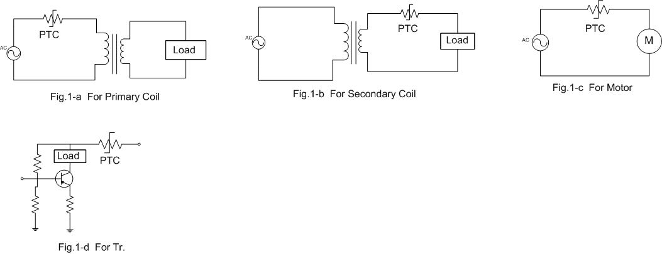
■ EXAMPLE OF APPLICATION 应用示例
图Ⅰ-1 For Primary Coil 图Ⅰ-2 For Secondary Coil 图Ⅰ-3 For Micromotor
初级线圈保护 次级线圈保护 微电机保护
图Ⅰ-5 For Telecom
通讯设备保护
图Ⅰ-4 For Tr.
晶体管保护

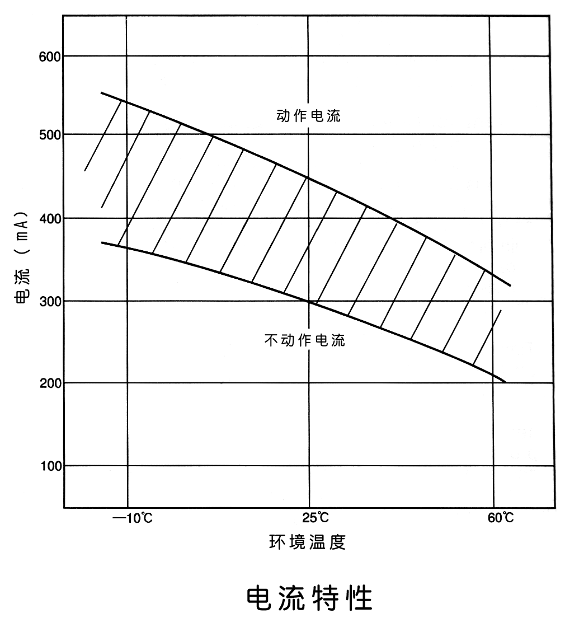
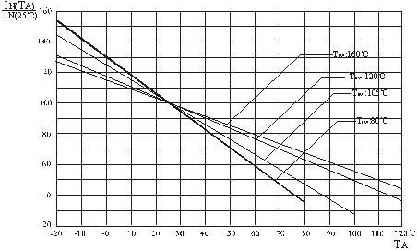
T_{A}
I_{T} ( I_{N} )
Trip Current动作电流 ( I_{T} )
No-operating Current不动作电流 (I_{N})
图Ⅱ Current Characteristics电流特性

■ PART NUMBERING 产品编号
WMZ12A（Ⅰ/Ⅱ） | - | 120 | SL | 15R | M | U | U | 200 | B | 5 | - | G | 6 | B
⑴ ⑵ ⑶ ⑷ ⑸ ⑹ ⑺ ⑻ ⑼ ⑽ ⑾ ⑿ ⒀

⑴ Series 系列：WMZ12A（Ⅰ/Ⅱ/Ⅲ）过流、过热、过压保护系列热敏电阻
⑵ Curie Temp. 居里温度：50 - 50℃ 75 - 75℃ 85 - 85℃ 105 - 105℃ 120 - 120℃
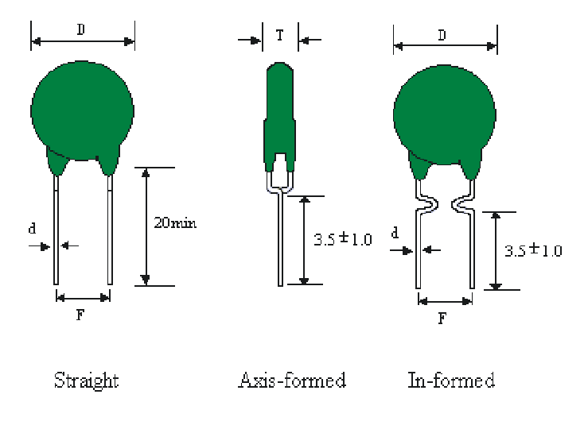
⑶ Max Diameter外径D_{max}：S - Φ4.5 A - Φ6.5 B - Φ8.5 LB-Φ10 M-Φ11.5 SL-Φ14.5
⑷ Rated Zero Power Resistance额定零功率电阻R_{N}：1R0- 1Ω 4R7-4.7Ω 15R-15Ω 101-100Ω
⑸ Tolerance of Resistance 电阻值允差： V - ±25% M - ±20% K - ±10%
⑹ Shape of Leads引线形状：U - In-formed内弯 S - Straight直线 A - Axis-formed轴弯
⑺ Leads material引线材质：U：Cu 铜线 (P：Cp 钢线)
⑻ Max. Non Operating Current 最大不动作电流：200-200mA 060-60mA 008-8mA
⑼ Packing Type 包装形式：B - Bulk 散装 (A - Ammo 条带 R - Reel 盘带)
⑽ Leads Length引线长度 5：5mm （10：10mm）
⑾ Coating Material包封材料：S-Black Silicone黑色硅树脂 G-Green Silicone绿色硅树脂
P-PF Resin酚酫树脂 E-Epoxy改良树脂 N-No Coating不包封
⑿ Leads Diameter 引线直径：5-Ф0.5 6-Ф0.6 8-Ф0.8 1-Ф1.0
⒀ Leads Distance 引线间距：A-2.5 B-5.0 C-7.5 D-10.0

■ SPECIFICATION S TABLE规格表

☆WMZ12A (Ⅰ)
For Over Current Protection of the Adaptor (Primary Coil) / Charger / Watt-hour Meter / Multimeter / Micromotor and Transistor etc.
主要用于变压器（适配器）初级线圈 / 充电器 / 电能表 / 数字万用表 / 微电机和晶体管过流保护

No.  序号 | Part No.  产 品 编 号 | Max.  Non Operating  Current at 60℃  最大不动作电流  I_{N} ( mA ) | Trip Current  at 25℃  动作电流  I_{T} ( mA ) | Rated  Zero Power  Resistance  额定零功率电阻  R_{N} (Ω) | Max. Permissible  Current at V_{Max}  最大许可电流  I_{Max} ( A ) | 外形尺寸  Dimension ( mm)
 |  |  |  |  |  | D_{Max} | T_{Max} | d^{±0.05} | F^{±1}
Max. Operating Vol. 最大工作电压 V_{Max} = 265V_{AC}; Curie Temp. 居里温度 T_{c} = 80℃±7℃
1 | WMZ12A-222M002 | 2 | 8 | 2200±20% | 0.25 | 4.5 | 4.5 | 0.5 | 5.0
2 | WMZ12A-152M003 | 3 | 12 | 1500±20%
3 | WMZ12A-102M004 | 4 | 16 | 1000±20%
4 | WMZ12A-681M005 | 5 | 20 | 680±20%
5 | WMZ12A-471M006 | 6 | 24 | 470±20%
6 | WMZ12A-151M025 | 25 | 100 | 150±20% | 1.00 | 8.5 | 4.5 | 0.6 | 5.0
7 | WMZ12A-121M030 | 30 | 120 | 120±20%
8 | WMZ12A-101M035 | 35 | 140 | 100±20%
9 | WMZ12A-82RM040 | 40 | 160 | 82±20%
10 | WMZ12A-68RM045 | 45 | 180 | 68±20%
11 | WMZ12A-25RM065 | 65 | 260 | 25±20%

No.  序号 | Part No.  产 品 编 号 | Max.  Non Operating  Current at 60℃  最大不动作电流  I_{N} ( mA ) | Trip Current  at 25℃  动作电流  I_{T} ( mA ) | Rated  Zero Power  Resistance  额定零功率电阻  R_{N} (Ω) | Max. Permissible  Current at V_{Max}  最大许可电流  I_{Max} ( A ) | 外形尺寸  Dimension ( mm)
 |  |  |  |  |  | D_{Max} | T_{Max} | d^{±0.05} | F^{±1}
Max. Operating Vol. 最大工作电压 V_{Max} = 265V_{AC}; Curie Temp. 居里温度 T_{c} = 105℃±7℃
12 | WMZ12A-221M020 | 20 | 50 | 220±20% | 0.25 | 4.5 | 4.5 | 0.5 | 5.0
13 | WMZ12A-151M025 | 25 | 65 | 150±20%
14 | WMZ12A-101M030 | 30 | 75 | 100±20%
15 | WMZ12A-221M025 | 25 | 65 | 220±20% | 0.30 | 5.5 | 4.5 | 0.6 | 5.0
16 | WMZ12A-151M030 | 30 | 75 | 150±20%
17 | WMZ12A-121M035 | 35 | 88 | 120±20%
18 | WMZ12A-101M040 | 40 | 100 | 100±20%
19 | WMZ12A-75RM045 | 45 | 115 | 75±20%
20 | WMZ12A-68RM050 | 50 | 125 | 68±20%
21 | WMZ12A-47RM055 | 55 | 138 | 47±20%
22 | WMZ12A-221M025 | 25 | 65 | 220±20% | 0.40 | 6.5 | 4.5 | 0.6 | 5.0
23 | WMZ12A-151M035 | 35 | 88 | 150±20%
24 | WMZ12A-101M045 | 45 | 115 | 100±20%
25 | WMZ12A-68RM055 | 55 | 138 | 68±20%
26 | WMZ12A-121M050 | 50 | 125 | 120±20% | 1.00 | 8.5 | 4.5 | 0.6 | 5.0
27 | WMZ12A-101M055 | 55 | 138 | 100±20%
28 | WMZ12A-82RM060 | 60 | 150 | 82±20%
29 | WMZ12A-62RM075 | 75 | 188 | 62±20%
30 | WMZ12A-39RM085 | 85 | 213 | 39±20%
31 | WMZ12A-22RM100 | 100 | 250 | 22±20%
32 | WMZ12A-22RM120 | 120 | 300 | 22±20% | 1.60 | 11.5 | 4.5 | 0.6 | 5.0/7.5
33 | WMZ12A-15RM130 | 130 | 325 | 15±20%
34 | WMZ12A-10RM140 | 140 | 350 | 10±20%
35 | WMZ12A-8R2M150 | 150 | 375 | 8.2±20%
36 | WMZ12A-18RM150 | 150 | 375 | 18±20% | 2.50 | 14.5 | 5.0 | 0.6 | 5.0/7.5
37 | WMZ12A-15RM160 | 160 | 400 | 15±20%
38 | WMZ12A-12RM170 | 170 | 425 | 12±20%
39 | WMZ12A-10RM180 | 180 | 450 | 10±20%
40 | WMZ12A- 6R8M200 | 200 | 500 | 6.8±20%
Max. Operating Vol. 最大工作电压 V_{Max} = 265V_{AC}; Curie Temp. 居里温度 T_{c} = 120℃±7℃
41 | WMZ12A-101M040 | 40 | 80 | 100±20% | 0.30 | 5.5 | 4.5 | 0.6 | 5.0
42 | WMZ12A-75RM045 | 45 | 90 | 75±20%
43 | WMZ12A-62RM050 | 50 | 100 | 62±20%
44 | WMZ12A-151M040 | 40 | 80 | 150±20% | 0.40 | 6.5 | 5.0 | 0.6 | 5.0
45 | WMZ12A-101M050 | 50 | 100 | 100±20%
46 | WMZ12A-68RM060 | 60 | 120 | 68±20%
47 | WMZ12A-47RM090 | 90 | 180 | 47±20% | 1.60 | 11.5 | 5.0 | 0.6 | 5.0/7.5
48 | WMZ12A-39RM100 | 100 | 200 | 39±20%
49 | WMZ12A-33RM110 | 110 | 220 | 33±20%
50 | WMZ12A-22RM130 | 130 | 260 | 22±20%
51 | WMZ12A-15RM145 | 145 | 290 | 15±20%
52 | WMZ12A-10RM160 | 160 | 320 | 10±20%
53 | WMZ12A-8R2M170 | 170 | 340 | 8.2±20%
54 | WMZ12A-22RM180 | 180 | 360 | 22±20% | 2.50 | 14.5 | 5.0 | 0.6 | 5.0/7.5
55 | WMZ12A-15RM200 | 200 | 400 | 15±20%
56 | WMZ12A-10RM220 | 220 | 440 | 10±20%
57 | WMZ12A-8R2M240 | 240 | 480 | 8.2±20%
58 | WMZ12A-6R8M260 | 260 | 520 | 6.8±20%

☆WMZ12A (Ⅱ)

For Over Current Protection of Telecom 主要用于通信设备过流保护

焊封型  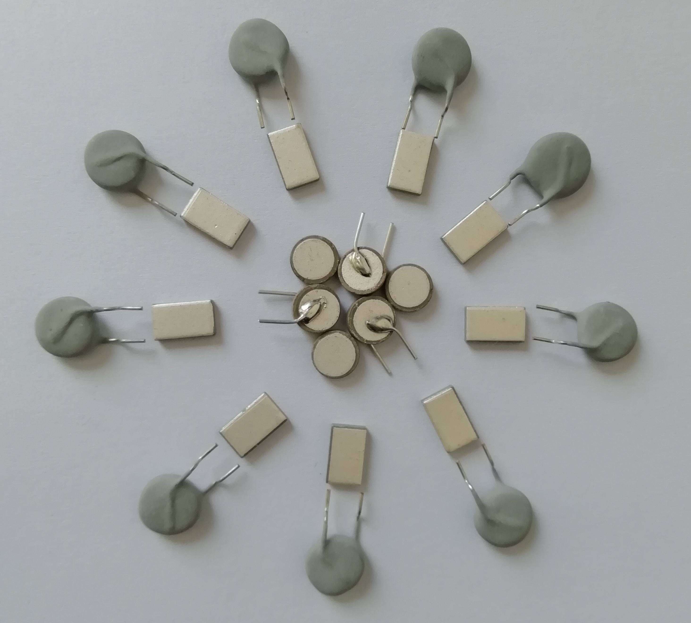  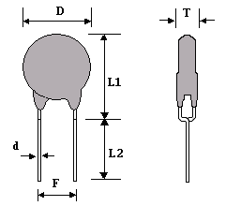 | 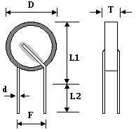  焊片型
圆芯片型  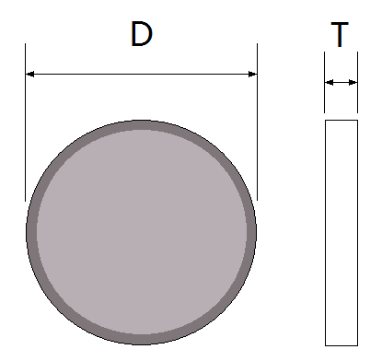 | 方芯片型  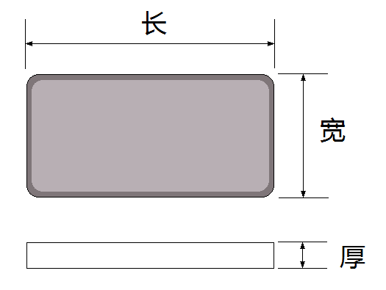

No.  序号 | Part No.  产 品 编 号 | Rated Zero  Power Resistance  额定零功率  电阻  R_{N}@25℃ | Max. Non Operating  Current  最大不动作电流  I_{N}( mA ) |  | Trip Current  at 25℃  动作电流  I_{T} ( mA ) | Tripping time  at max current  最大电流下  的动作时间  T(Set) | Max.  Current  最大电流  I_{Max}(A) | Max.  Voltage  最大电压V_{Max}(V) | Dimension ( mm )  外形尺寸
No.  序号 | Part No.  产 品 编 号 | Rated Zero  Power Resistance  额定零功率  电阻  R_{N}@25℃ | @25℃ | @40℃ |  |  |  |  | D_{Max} | T_{Max} | d^{±0.05} | F^{±1}
1 | WMZ12A-85LB10RM150 | 10Ω±20% | 150 | 120 | 300 | 0.55 | 3.0 | 250 | 10.0 | 5.0 | 0.6 | 5
2 | WMZ12A-85B12RM060 | 12Ω±20% | 90 | 60 | 160 | 0.2 | 2.0 | 250 | 9 | 5.0 | 0.6 | 5
3 | WMZ12A-105B18RM110 | 18Ω±20% | 135 | 110 | 270 | 0.18 | 3.0 | 250 | 8.5 | 5.0 | 0.6 | 5
4 | *WMZ12A-70LB20RM070 | 20Ω±20% | 110 | 70 | 200 | 0.3 | 3.0 | 250 | 10.5 | 5.0 | 0.6 | 5
5 | WMZ12A-110B35RM070 | 35Ω±20% | 90 | 70 | 230 | 0.45 | 3.0 | 250 | 9 | 5.0 | 0.6 | 5
6 | *WMZ12A-108B35RM070 | 35Ω±20% | 90 | 70 | 230 | 0.45 | 4.6 | 245 | 9 | 5.0 | 0.6 | 5
7 | *WMZ12A-85LB50RM060 | 50Ω±20% | 75 | 60 | 150 | 0.2 | 3.0 | 250 | 9.5 | 5.0 | 0.6 | 5
8 | *WMZ12A-85LB50RM060 | 50Ω±20% | 75 | 60 | 150 | 0.2 | 3.0 | 380 | 9.5 | 5.0 | 0.6 | 5
9 | *WMZ12A-85LB55RM060 | 55Ω±20% | 70 | 60 | 150 | 0.2 | 3.0 | 250 | 9.5 | 5.0 | 0.6 | 5
10 | *WMZ12A-85LB55RM060 | 55Ω±20% | 70 | 60 | 150 | 0.2 | 3.0 | 650 | 10.0 | 5.0 | 0.6 | 5
11 | *WMZ12A-110B35RM070 | 35Ω±20% | 100 | 70 | 230 | 0.2 | 3.0 | 245 | 7.2 | 3.5 | 0.5 | 4.5
12 | WMZ12A-110B50RM090 | 50Ω±20% | 90 | 60 | 180 | 0.15 | 4.5 | 250 | 7.2 | 3.5 | 0.5 | 4.5
13 | WMZ12A-110H35RM060 | 35Ω±20% | 90 | 60 | 180 | 0.2 | 2.5 | 230 | 6.3 | 3.5 | 0.5 | 4.5
14 | *WMZ12A-110LB50RM060 | 50Ω±20% | 90 | 60 | 190 | 0.2 | 2.5 | 250 | 8.4 | 3.5 | 0.6 | 5.5
15 | *WMZ12A-115B25RM085 | 25Ω±20% | 130 | 85 | 260 | 0.3 | 3.0 | 250 | 7.2 | 3.5 | 0.5 | 4.5
16 | *WMZ12A-110B35RM070 | 35Ω±20% | 110 | 70 | 230 | 0.2 | 3.0 | 250 | 7.2 | 2.2 | / | /
17 | *WMZ12A-85C10RM100 | 10Ω±20% | 130 | 100 | 300 | 0.2 | 3.0 | 250 | 长*宽*厚=8.7*5.3*1.9

Other Characteristics 其它电性能参数:
Over Current Withstanding 耐工频电流能力: : 3Arms / 220Vrms 20 times (60s On, 300s Off)
Lighting Surges 耐冲击电流能力: : 10/310μS 1.5KV 37.5A 10 times or 10/1000μS 1.0KV 25A 30 times
Over Vol. Withstanding 耐工频电压能力: : 250Vrms / 3A / 15 min.
Inducted Vol. Withstanding 耐高压感应能力:: 650Vrms / 1.1A 20 times (1s On, 60s Off) (For only the items with * 仅适用于标有*号品种)

4.

